**Flugger Instructions**

**CAUTION- The pneumatic cylinders in the Flugger are very powerful and could cause injury should a user attempt to interfere with them . Never defeat the safety door interlock switch or attempt to operate the machine with the covers removed. Should work need to be done on the machine, turn off the compressor and bleed the air from the system before removing the covers.**

1. Plug in power cord. Air compressor should run until tank pressure reaches approx. 120 psi. It will stop and then turn back on after plugging a few trays when pressure falls below 90psi.
2. Ensure that both the tray and ram platforms are in their upper raised position so that vials and plugs can be loaded, assuming the machine is empty.
3. If the platforms are not raised follow these steps:
   1. Ensure that tray loading door is closed
   2. Turn on switch labeled “power”
   3. Turn red estop switch clockwise so that it pops out
   4. Ram switch should be to left
   5. Tray switch should be to left

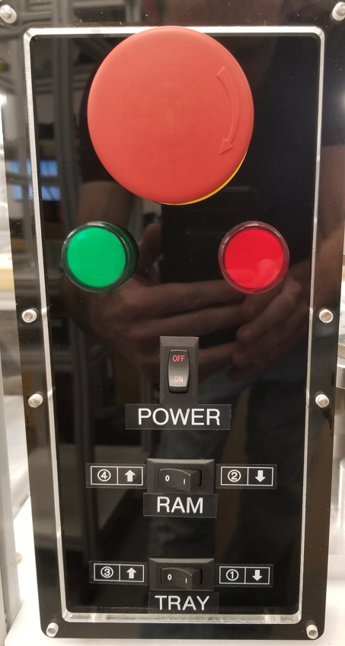

ESTOP switch

Fig 1 Flugger control Panel

1. Now that the platforms are raised, first depress the Estop switch. The Estop switch when depressed cut power to the main air valve and will power the door switch and locks so the door can be opened.
2. Pull down the tray pusher handle , and insert a tray of vials with the folded cardboard edge facing out ( towards the user) as shown in the picture. The tray pusher can be snapped into place in the open position. After the vial tray is fully inserted, raise the tray pusher handle and push gently on the handle to ensure the vials are seated properly in the Flugger
3. Fill the plug tray with plugs and insert
4. Close the outer door

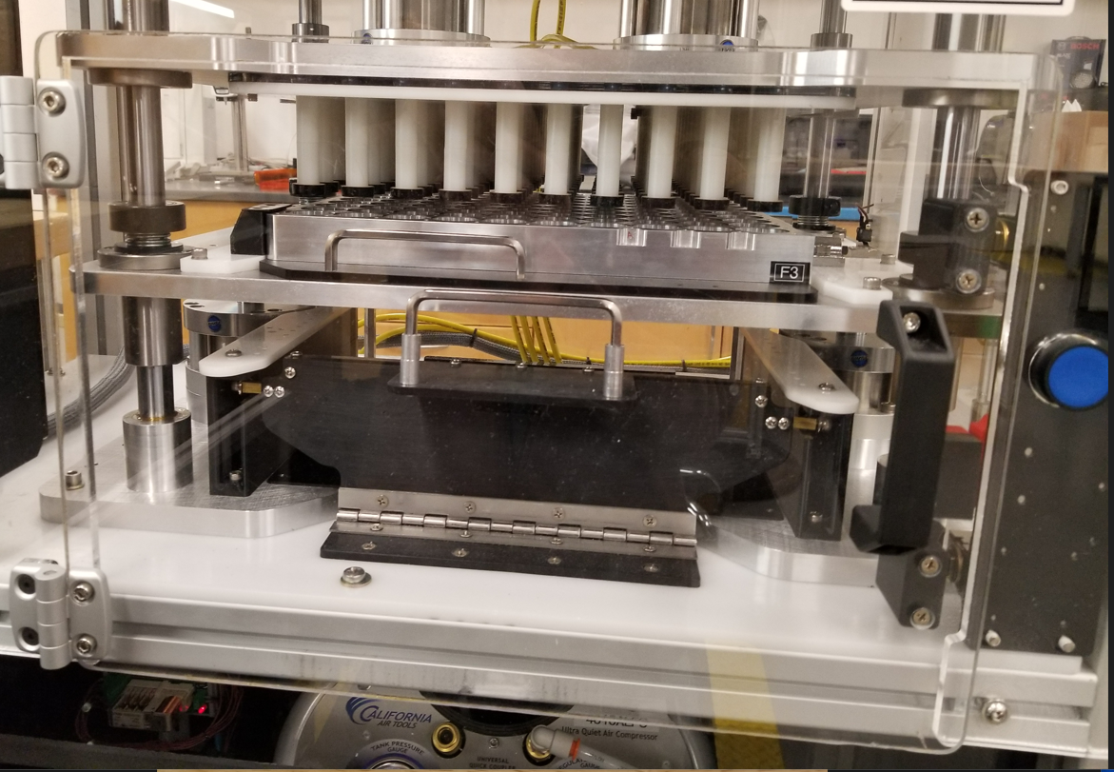

Ram platform

Tray platform

Tray pusher and handle

Door Switch

Outer door and handle

Fig 2 Door and loading components

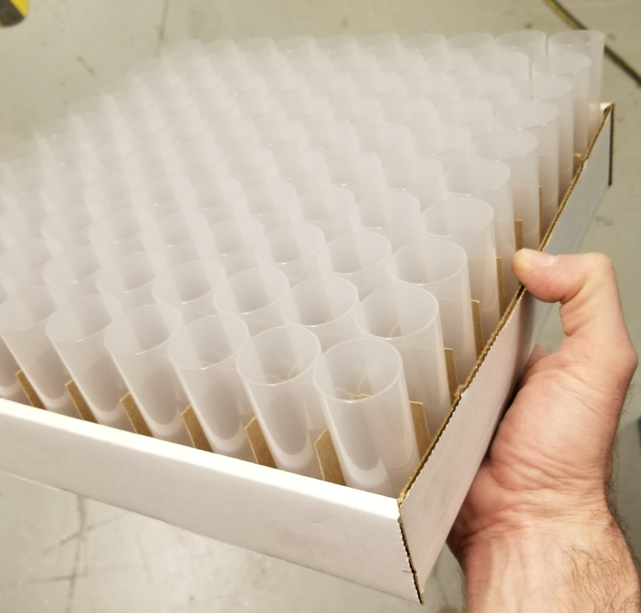

Folded seam

Vial Tray Insertion Direction

Fig 3 Vial Tray- make sure the folded seam is towards you

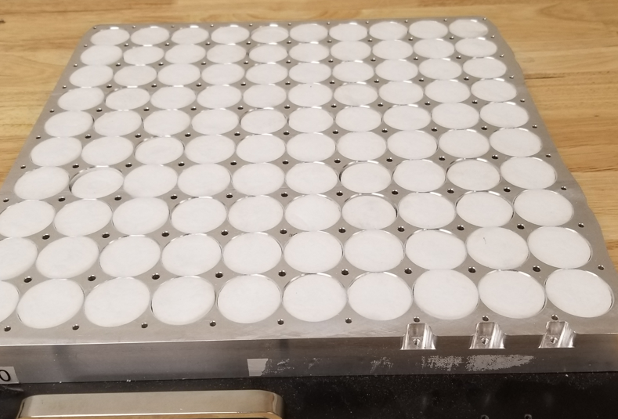

Plug Tray Insertion Direction

Fig 4 Plug tray

8. Now that both the plug tray and vial trays are loaded, follow the sequence shown on the control panel. Note that both platforms should still be in the “up” position. Go through the sequence below, observing the proper order of steps.

* 1. Turn red estop switch clockwise so that it pops out-note that the green light should turn on, this indicates that you are ready to plug.
  2. Tray switch should be pushed to right “1” which will lower the tray platform
  3. Ram switch should be pushed to right “2” which will lower the ram platform and push the plugs into the vials.
  4. Tray switch should be pushed to left “3” which will raise the tray past the plugs
  5. Ram switch should be pushed to left “4” which will raise the ram through the tray
  6. The plugged tray is now ready. Depress the Estop switch and open the outer door.
  7. Remove the plugged vial tray and the empty plug tray.
  8. Install another filled plug tray and vial tray to continue plugging.

 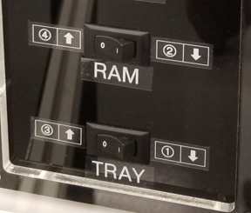

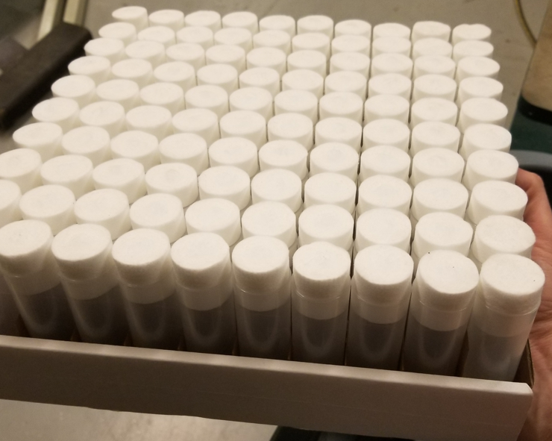

Fig 5 Control panel switch positions, and Plugged tray

**Revision History**

|  |  |  |
| --- | --- | --- |
| Date | Description | Author |
| 2023/04/04 | Initial Release | Jon Arnold |